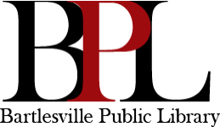
To help assure the use and enjoyment of the Bartlesville Public Library and the safety of patrons and staff, the following guidelines for patrons have been established:

1. Respect the rights of all library users.
2. Use moderate voice levels while in the Library.
3. Use Library furniture, equipment, and materials appropriately. Vandalism or misuse of Library property and grounds will not be tolerated. Appropriate corrective action, as determined by staff, will be taken.
4. Walk, do not run, in the Library.
5. Keep skateboards, skates, bicycles, etc., outside the Library building. 6. Keep tobacco products, and pets outside the Library building.
7. Children under the age of 10 must be attended while in the Library. (See "Safety of Children" Policy)
8. Cell phones should be set on silent or vibrate while in the Library.
9. Headphones must be worn while using audio devices (including PCs). Sound volume should be kept low so as not to be audible to others.
10. Shoes and appropriate attire, as determined by staff, are required. 11. Selling or soliciting for money, items, or services will not be tolerated.

Individuals, in violation of the Principles of Conduct, will receive a verbal warning. If the problem persists, individuals will be asked to leave the Library.

The following items may not be brought into the Library: Weapons
Alcohol, marijuana, and illegal drugs
Pets or animals (except use of service animals as outlined by ADA: http://www.ada.gov/service_animals_2010.htm

Reviewed March 2023

